|  |  |
| --- | --- |
| Ex:No:1 | Creating an ebook library website using HTML |
| Date:  30/07/2021 |

**Aim :**

To create the ebook library website using html.

**Procedure:**

1)image map-used to redirect to book sections page

2)Table-to show the book details

3)Form-To create the login/signup form

4)Fieldset,legend-To place input element in the form

5)input

Date-To get the date as the input

Radio-To get the gender input

check-To accept the terms and condition

tel-for phone number

6)video-To insert the ebook explanation video in the home page.

7)header and footer-To create the header and footer for this website

**Program:**

**1.index.html:**

<!DOCTYPE html>

<html>

<head>

    <title>ebook library</title>

        <style>

            table,

            td,

            tr {

                border: 3px solid rgb(255, 251, 24);

                border-collapse: collapse;

                color: rgb(0, 0, 0);

                text-align: center;

                font-weight: bold;

            }

        </style>

</head>

<body style="width: 80;background: url('https://images.pexels.com/photos/7171398/pexels-photo-7171398.jpeg?auto=compress&cs=tinysrgb&dpr=2&w=500');font-size: 4vh;">

    <header style="margin: 0;text-align: center">

        <a href="./login.html"><button style="float: right;padding: 1.5vw 1.5vh;width: 10%;font-weight: bold;">login</button></a>

        <h2 style="text-align: center;margin-top: 8vh;">EBook Library</h2>

    </header></br>

    <div style="padding:0 0 1vh 0;margin-bottom: 4vh;text-align: center;">

        <img style="width: 100%;height: 75vh;" usemap="#books"

            src="https://images.pexels.com/photos/207662/pexels-photo-207662.jpeg?auto=compress&cs=tinysrgb&dpr=2&w=500"

            width="100%" height="500vh" style="margin:0 auto;">

        <map name="books">

            <area shape="rect" coords="84,84,84,84" href="./sections/art.html">

            <area shape="rect" coords="114,294,370,450" href="./sections/business.html">

        </map>

        <br /><br />

    <h3>please select book from the above books shelf picture</h3>

    </div>

    <div style="text-align: center;margin-top:0">

        <pre>

           <h3>available book sections</h3>

        </pre>

    </div>

    <table style="width: 90%;height: 75vh;font-size: 4vh;margin: 0 auto;">

        <tr>

            <td colspan="2">section name</td>

            <td colspan="2">No of books</td>

            <td>section no</td>

        </tr>

        <tr>

            <td colspan="2">art</td>

            <td colspan="2">500</td>

            <td>1</td>

        </tr>

        <tr>

            <td colspan="2">business</td>

            <td colspan="2">267</td>

            <td>2</td>

        </tr>

        <tr>

            <td colspan="2">mystery</td>

            <td colspan="2">503</td>

            <td>3</td>

        </tr>

        <tr>

            <td colspan="2">science</td>

            <td colspan="2">768</td>

            <td>4</td>

        </tr>

        <tr>

            <td colspan="2">computer</td>

            <td colspan="2">500</td>

            <td>5</td>

        </tr>

    </table>

    <br/><br/>

    <iframe style="width: 100%;height: 75vh;" src="https://www.youtube.com/embed/GZosR1twLJs" title="YouTube video player"

        frameborder="0" allow="accelerometer; autoplay; clipboard-write; encrypted-media; gyroscope; picture-in-picture"

        allowfullscreen></iframe>

    <br />

    <footer style="margin: 0;padding: 10px 15px;text-align: center;font-weight: bold;">

        <p>Thank you</p>

    </footer>

</body>

</html>

**2.login.html**

<!DOCTYPE html>

<html>

<head>

    <title>login</title>

</head>

<body style="background:url('https://images.pexels.com/photos/4855370/pexels-photo-4855370.jpeg?auto=compress&cs=tinysrgb&dpr=2&w=500');color: aliceblue;font-size: 3.5vh;">

    <div style="margin-top: 15vh;">

        <form>

            <h2 style="text-align: center;font-size: 6vh;padding: 2vw 2 vh;">Login</h2>

            <fieldset style="width: 50%;margin: 0 auto;">

                <legend for="email">email :</legend>

                <input style="width: 93%;padding: 1.5vh 1.5vw;" type="text" name="email">

            </fieldset>

            <fieldset style="width: 50%;margin: 0 auto;">

                <legend for="password">password :</legend>

                <input style="width: 93%;padding: 1.5vh 1.5vw;" type="text" name="password">

            </fieldset>

            <fieldset style="width: 50%;margin: 0 auto;">

                <legend for="confirm_password">confirm password :</legend>

                <input style="width: 93%;padding: 1.5vh 1.5vw;" type="text" name="confirm_password">

            </fieldset>

            <div style="width: 50%;margin: 0 auto;margin-top:1vw">

                <input type="checkbox" value="agree">

                <label>I agree</label><br /><br />

                <a href="./signup.html" style="color: rgb(255, 255, 255);font-size: 4vh;font-weight: bold;">Create an account</a><br/><br/>

                <input type="submit" value="login" style="width: 100%;padding: 1.5vh 1.5vw;">

            </div>

        </form>

    </div>

</body>

</html>

**3.signup.html**

<!DOCTYPE html>

<html>

    <head>

        <title>sign up</title>

    </head>

    <body style="background-image: url('https://images.pexels.com/photos/4855370/pexels-photo-4855370.jpeg?auto=compress&cs=tinysrgb&dpr=2&w=500');color: aliceblue;font-size: 3.5vh;">

        <div style="margin-top: 15vh;">

            <h2 style="text-align: center;font-size: 6vh;padding: 2vw 2vh;">sign up</h2>

            <form>

                <fieldset style="width: 50%;margin: 0 auto;">

                   <legend for="first name">first name :</legend>

                   <input style="width: 93%;padding: 1.5vh 1.5vw;" type="text" name="first name" style="outline:  none;">

                </fieldset>

                <fieldset style="width: 50%;margin: 0 auto;">

                    <legend for="last name">last name :</legend>

                    <input style="width: 93%;padding: 1.5vh 1.5vw;" type="text" name="last name">

                </fieldset>

                <fieldset style="width: 50%;margin: 0 auto;">

                    <legend for="email">email :</legend>

                    <input style="width: 93%;padding: 1.5vh 1.5vw;" type="text" name="email">

                </fieldset>

                <fieldset style="width: 50%;margin: 0 auto;">

                    <legend for="password">password :</legend>

                    <input style="width: 93%;padding: 1.5vh 1.5vw;" type="text" name="password" >

                </fieldset>

                <fieldset style="width: 50%;margin: 0 auto;">

                    <legend for="name">phone :</legend>

                    <input style="width: 93%;padding: 1.5vh 1.5vw;" type="phone" name="name">

                </fieldset>

                <div style="width: 50%;margin: 0 auto;margin-top:1vw">

                    <fieldset style="width: 100%;margin: 0 auto;margin-left: -1vw;">

                        <legend>gender</legend>

                        <input type="radio" name="gender" value="male">

                        <label>male</label>

                        <input type="radio" name="gender" value="female">

                        <label>female</label>

                        <input type="radio" name="gender" value="other">

                        <label>other</label>

                    </fieldset>

                    <fieldset style="width: 100%;margin: 0 auto;margin-left: -1vw;">

                       <legend>Date of Birth</legend>

                       <input type="date">

                    </fieldset>

                    <br/><br/>

                    <input type="checkbox" value="agree">

                    <label>I agree</label><br />

                    <br/>

                    <a href="./login.html" style="color: rgb(255, 255, 255);font-size: 4vh;"*"*>registered user</a><br /><br />

                    <input type="submit" value="sign up" style="width: 100%;padding: 1.5vh 1.5vw;font-size: 3vh;">

                </div>

               </form>

        </div>

    </body>

</html>

**Output:**

**1.index.html**

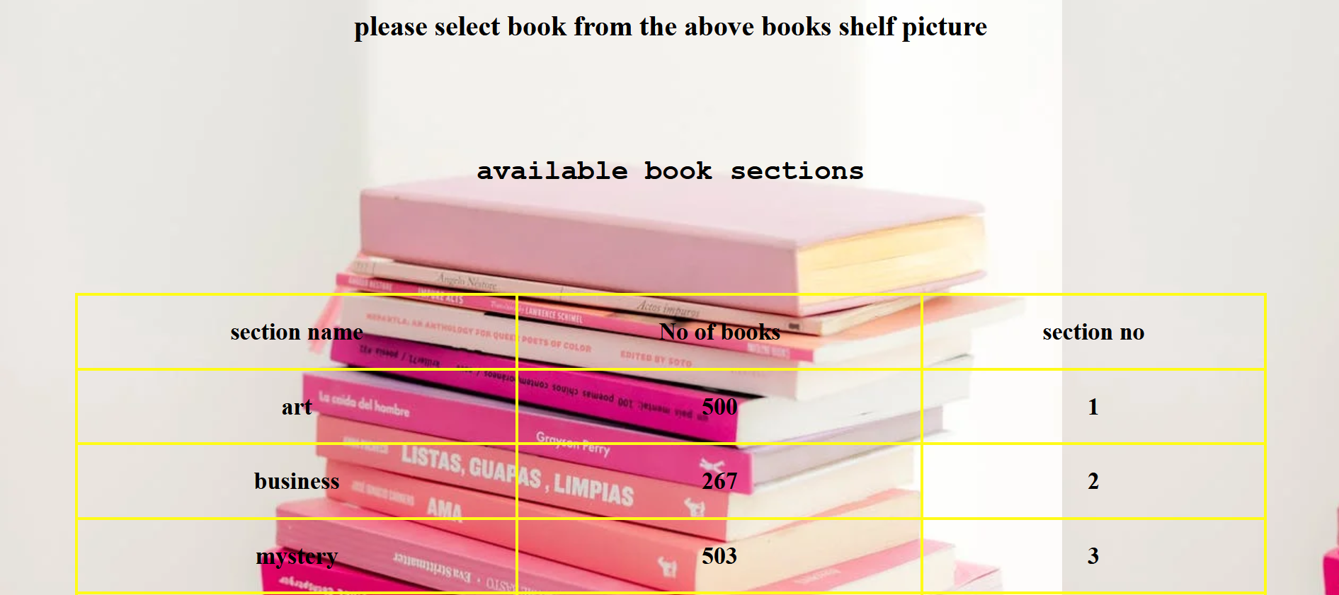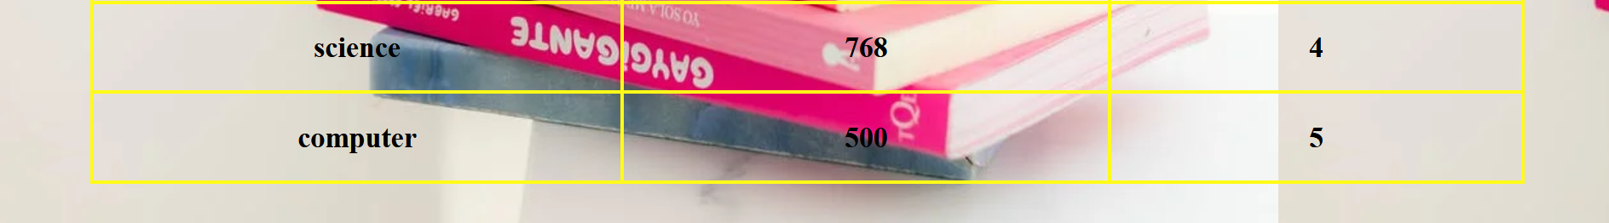

**2.Login.html**



**3.signup.html**



**Result:**

The above website is successfully completed and the output is verified.